**🎓 Education**

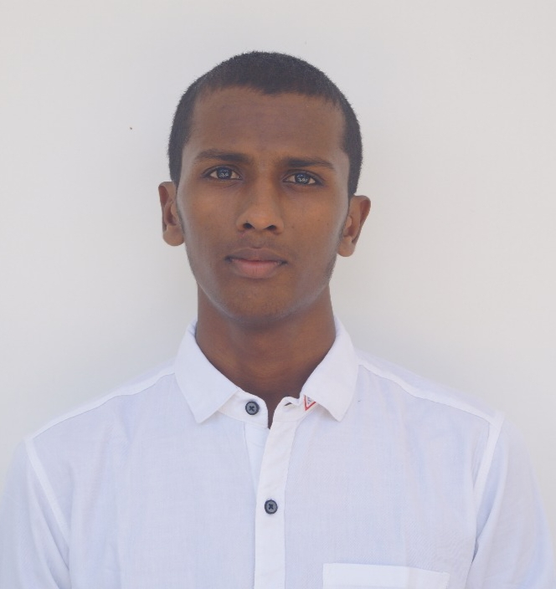

### B. Tech at Saveetha School of Engineering (Expected 2026)

2022-2026

📌 Coursework: Data Structures, Algorithms, Web Development, Database Management, Artificial Intelligence.

💡 Passionate about **Full Stack Web Development** with hands-on experience in **HTML, CSS, JavaScript, and backend technologies**. Constantly learning new frameworks to build efficient and scalable applications.

### INTERMEDIATE (MPC - Maths, Physics, Chemistry) by

BALAJI DASETTI

Chaitanya college.

# 

# 📞 Contact

📱+91-7995376849

📧 dasettisribalu@gmail.com

🔗 Github:[Balaji431](https://github.com/Balaji431)

🔗 LinkedIn**:** [balaji-d-1675a9324](https://www.linkedin.com/in/balaji-d-1675a9324/)

📍14-Mulakalacheru, pin-517390

# 👨‍💻 About Me

I am a passionate web developer with a strong interest in creating interactive, responsive, and user-friendly websites. I specialize in frontend and backend development, focusing on optimizing user experience. I love solving complex problems through code and continuously expanding my skills.

# ⚙️ Skills

* + Creativity

### Leadership

### Negotiation

.

# Experience

### **Full Stack Web Development Intern**

### 📅 **[Mention Duration, e.g., June 2024 – August 2024]**

### Completed an internship in **Full Stack Web Development**, gaining hands-on experience in building **responsive and dynamic websites**.

# 🛠 Technical Skills

### HTML, CSS, JavaScript (Basics), Responsive Web Design

### Node.js, Express.js (Basic Understanding), Database Management: MongoDB / MySQL

### **Programming Languages**

### C (Basic), Java (Basic)

### **Tools & Platforms**

### GitHub, Visual Studio Code

### Microsoft Office, Excel

# 📜 Certifications & Achievements

### 📜 **Oracle Certified Professional** – Oracle AI Vector Search Certified Professional (Valid until March 12, 2027). 📜 **Certificate of Participation** – Attended the **GEN-AI workshop** on February 12, 2025, at **Chennai Institute of Technology**, organized by **T.A.L.O.S.** 📜 **Internship Completion Certificate** – Successfully completed a **Full Stack Web Development internship**. 📜 **National Conference Speaker** – Presented a paper on **"5G and Its Impact on Digital India"** at a **conference on February 28, 2025**.